**https://0100.intechnite.com/**

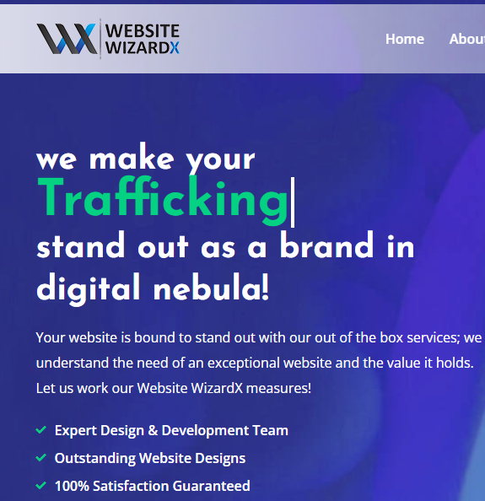

**We make your  
Business  
Stand out as a unique identity,  
globally!**

With us, your website is all set to make the impact you need. We understand today’s industry trends and are capable of building stunning websites. Explore the WebsiteWizardX to find out more!

**Top-Notch Designers & Developers  
Inspiring Web Design Layouts  
Decades of Industry Experience**

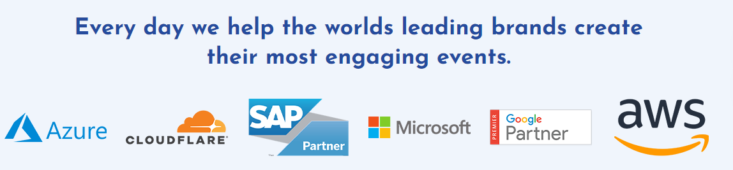

We have catered to globally renowned and market leading companies to meet their complex goals.

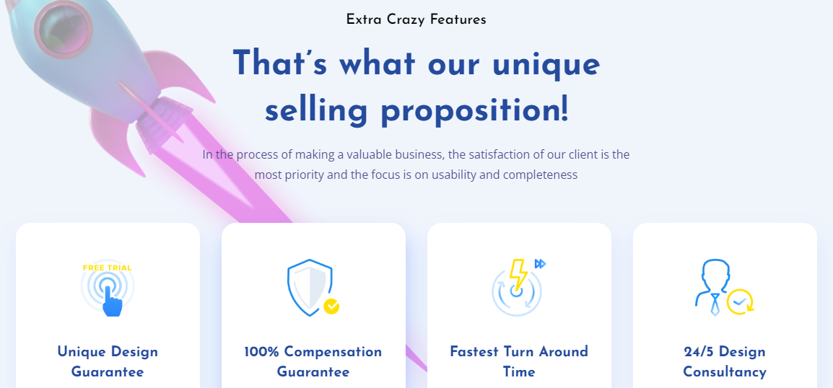  
Here is What You Get   
**By Choosing Us!**

WebsiteWizardX is the best place to make your strategic business goals a reality. By choosing us, you get:

|  |  |  |  |
| --- | --- | --- | --- |
| Unique Design Concepts | Industry-Specific Professionals | The Fastest Turn Around Time | 24/7 Dedicated Customer Support |

_____________________________________________________________________________________

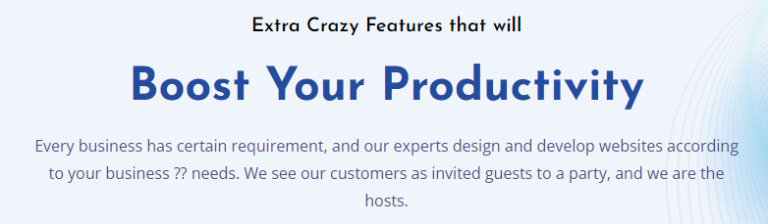

We Can Help You To  
**Unleash Real Business Potential**

Every customer comes with a unique requirement and from distinguished industry. No matter what kind of business you have, we take every project with complete ownership and deliver true results.

_____________________________________________________________________________________

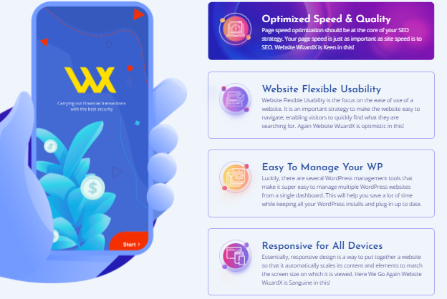

**Enriched Speed & Quality**

Every website that we build is up to the mark when it comes to ensuring industry trends and best practices where speed and quality comes first.

**Flexible & Friendly Usability**

We focus on making websites that are capable of captivating the visitors and making them explore your world with great ease and convenience.

**Easy Content Management System**

No matter what your content management needs are, you will get an intelligent, easy to use, and fast CMS with simple drag and drop features.

**Responsive & Cross-Platform Compatible**

In today’s digital world, potential customers come from different platforms and devices therefore, we build websites that run everywhere.

___________________________________________________________________________

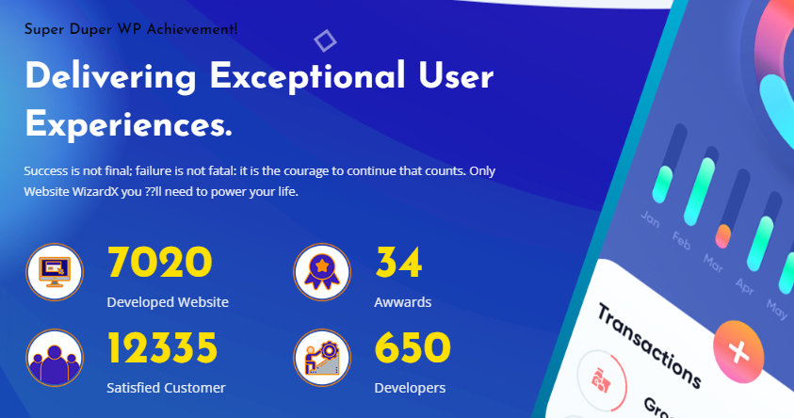

We Are Constantly Growing!

**We Have Made Considerable Progress  
In A Short Time**

Backed by years of experience, handpicked team of experts, and state-of-the-art technology, WebsiteWizardX has earned a proven track record.

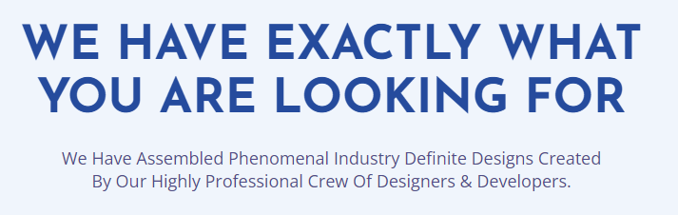

**We Have What It Takes  
To Build Memorable Experiences**  
Our handpicked designers and developers deliver only the extraordinary. That set us apart from others.

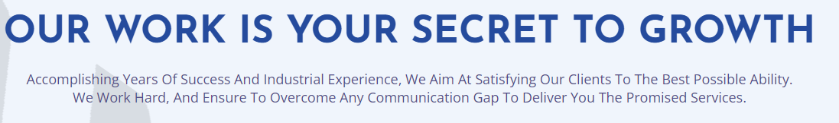

**Our Work Is Key to Our Clients’ Success**

We had the opportunity to serve numerous clients around the word. They belong to different industries and have their unique business ideas, goals, and problems. Take a look at what they say about us, you will see each one of them happy and satisfied.



Ready to Choose Your Desired Services?

**Take a look at these all-inclusive packages and pick the best.**

If you think you have a unique project that requires more or less than what’s included in these packages, talk to us, we can make a personalized package for you.

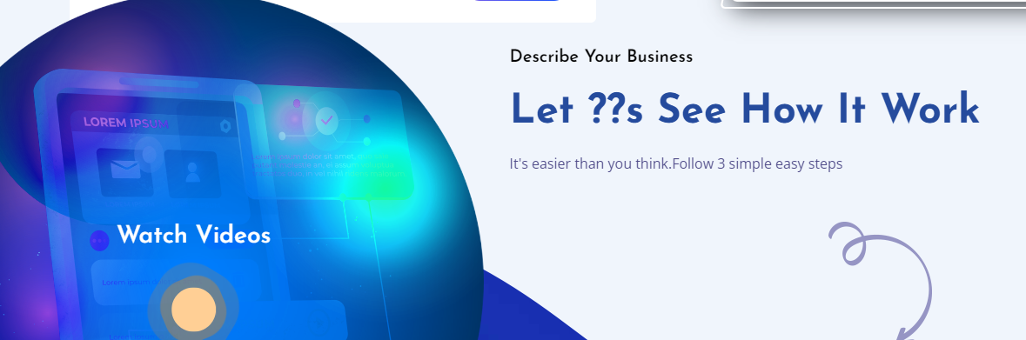

**Take A Look At  
Our Web Creation Process**

Its simple, productive, and collaborative.

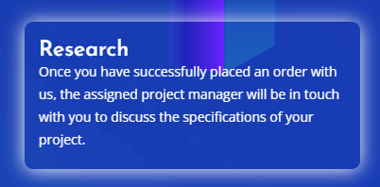

**Research**

Once you discuss and kickstart your project with us, we immediately dive into researching the industry and solutions that can help you to reach your goals.

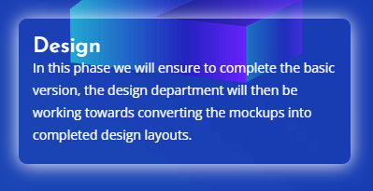  
**Design**

Next to sharing ideas and getting things approved by you, we start sketching initial design templates deliver them a head of the deadline stated.   
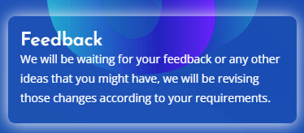

**Feedback**This is the moment when we allow you to take your time and review our work. This helps us in getting your input and feedback to make things perfect.

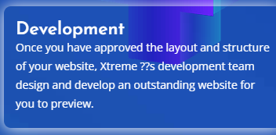

At this step, we address everything communicated in the feedback and move on to the development phase where our developers start building the website.

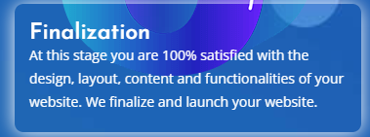

Once we are done with everything and have the website ready to go live, we share it with you and publish it on the internet with the world.

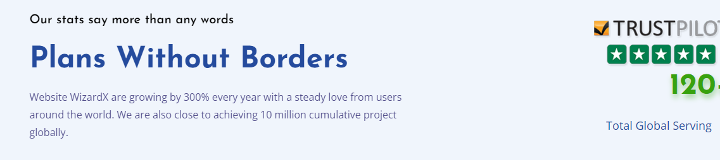

Our Unmatched Work History   
**Tells All That!**

WebsiteWizardX stands among few of today’s fastest growing web services and solutions providers. We serve global clients and have made swift progress at an unprecedented pace that reflects everywhere.

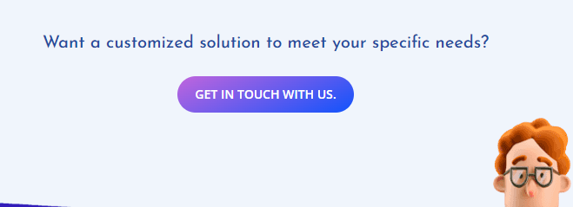

Inspired By Our Unmatched Capabilities?  
**GET IN TOUCH NOW!**



Our Happy Clients

**We Have 350+ Satisfied Customers  
Around the World**



**Technologies & Platforms We Have Mastered**

**https://0100.intechnite.com/about.html**

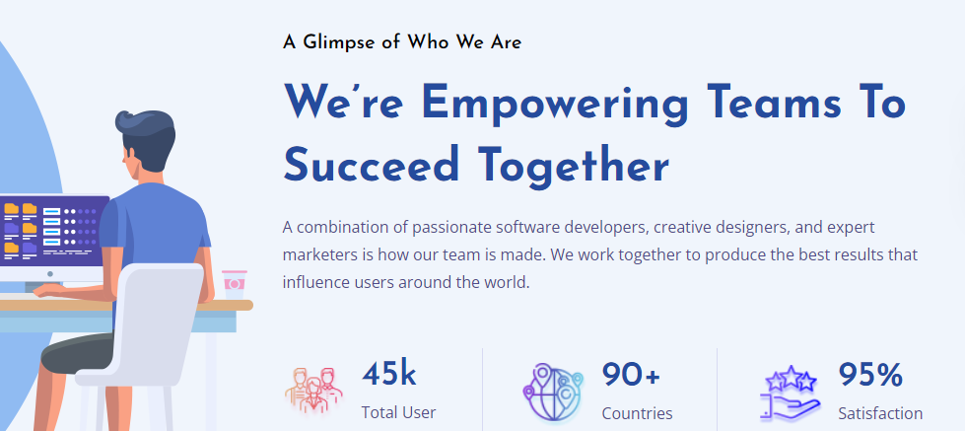

Get To Know More   
**About WebsiteWizardX Before  
You Give Us The Project**

WebsiteWizardX is a professional web services and solutions provider. We serve customers on a global scale and are known for providing businesses with intelligent and productive web solutions.

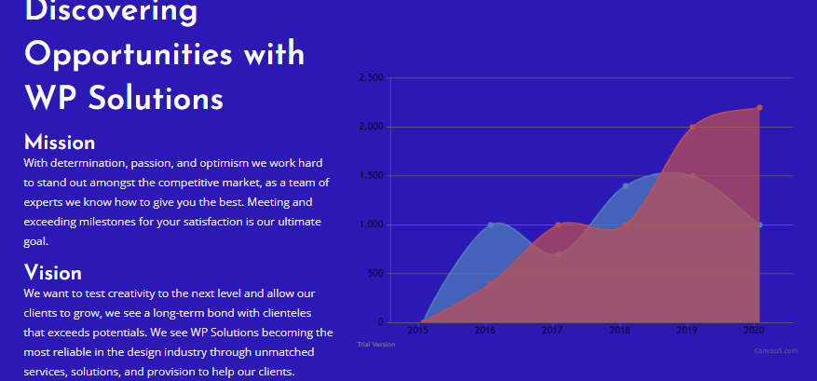

**We Enable Businesses To  
Compete Better In Today’s   
Digital Space  
  
Our Mission**

Our mission is to combine the unsurpassed experience, capabilities, and resources together to provide our clients with scalable and productive web solutions that are proven to give real-time results in a friendly budget.

**Our Vision**

We are a team of visionary tech enthusiasts who don’t just want to constant grow but contribute their professional capabilities to businesses that strive for performance, perfection, and proven results like never before.

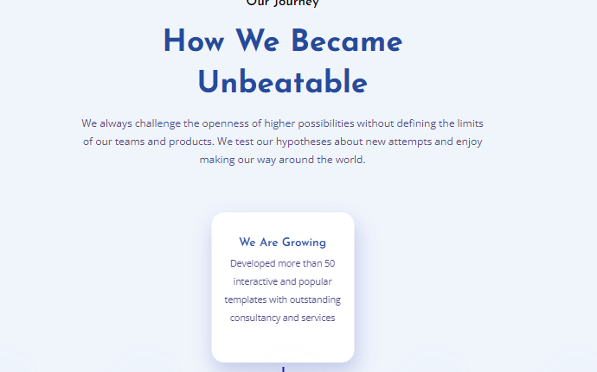

Our Successful Journey  
**Here is How We Became  
Invincible**

We are always open to new ideas and challenging projects. This not only allowed us to learn and develop ourselves but also grow rapidly in less time. It seems like we have just started but our efforts are now transforming into a great success.

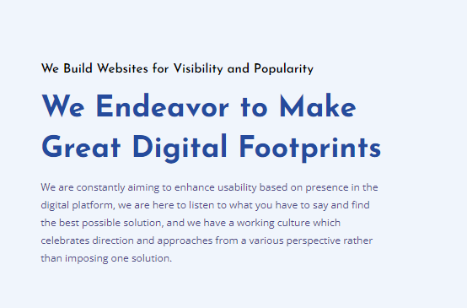

Our Work Brings Unimaginable Results  
**We Love To Work On Complex Projects  
And Deliver True Results**

We aim to incorporate industry’s best practices and approaches. This covers everything from the moment we start research to the moment we design, develop, test, and deliver the end product to the customer. Our recommended solutions encompass everything that you might not have in your mind which gives us an edge over others.

[**https://0100.intechnite.com/our-work.html**](https://0100.intechnite.com/our-work.html)

Nothing Required, Same content will be used from the sections on Home Page.

[**https://0100.intechnite.com/review.html**](https://0100.intechnite.com/review.html)

**Robert Ross**

The team at WebsiteWizardX handled our project perfectly! Every minute detail was given maximum attention that reflects in the final work. I highly recommend them for website development.  
**Stephen Jacob**WebsiteWizardX is the best team of web developers. They made it a reality for me to sell my products online with a professional eCommerce website. I am happy!  
**Emmo Rowen**

I am a creative artist who wanted to build a unique and simple website where my followers can find my work. I would say WebsiteWizardX delivered more than what I expected.

**Samantha Groover**

Thanks a lot WebsiteWizardX for helping us revamp our website. We have noticed significant growth since we went live with the website you built for us.

**Rodnie Forge**

I am completely amazed with your work. Everything that I explained in the brief and feedback was fixed and it looks pretty cool.

**George Mason**

It was a big decision for me to take my business online but WebsiteWizardX made this a opportunity for me, I don’t have words to thank them for their untiring efforts.

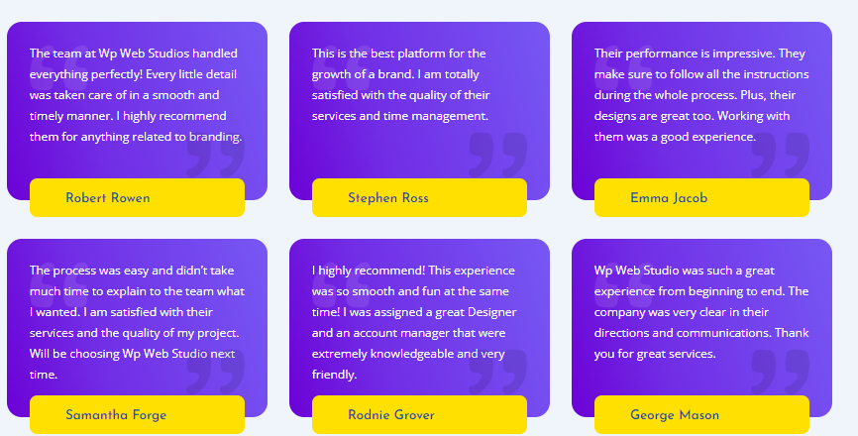

[**https://0100.intechnite.com/contact.html**](https://0100.intechnite.com/contact.html)



If you have something in your mind, reach out to us now. We will discuss and explain everything in detail.



**Get Quick Answers**You might find some of the general questions answered in this section.

**https://0100.intechnite.com/faqs.html**

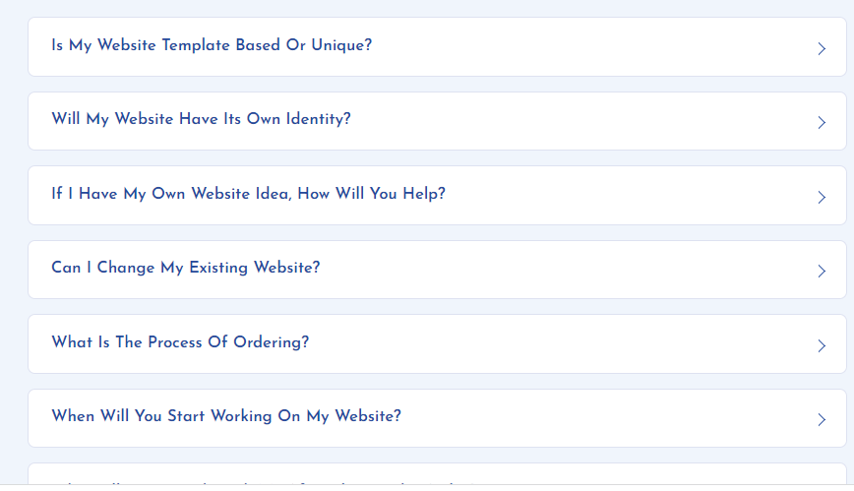

**Is My Website Template Based or Unique?**

We build 100% custom designed and developed websites that are unique from every corner.

**Will My Website Have Its Own Identity?**

Yes, your website will be built right according to the custom requirement provided to us.

**If I Have My Own Website Idea, How Will You Help?**

That’s great, our team of experts will take your ideas as inspirations and will deliver a cool concept.

**Can I Change My Existing Website?**

Yes, we can help you revamp your existing website without losing its key content and elements.

**What Is the Process of Ordering?**

Placing an order is quite simple as all you need is to call or send us an email.

**When Will You Start Working on My Website?**

We kickstart projects right after the moment we have received the initial payment.

**Who Will Be in Touch with Me After Placing the Order?**

You will get a dedicated account manager who will take care of your project and order issues.

**How Will the Designer Understand What I Want?**

Our team of designers will spend considerable time listening your ideas and understanding your concepts which makes things easier.

**How Many Website Samples Will I Receive?**

You will get three design samples during the first phase of designing when we submit initial design concepts.

**What Is the Procedure of Revisions?**

You can always reach out to the account manager assigned on your project in case of any revisions.

**When Will I Get My Final Website?**

Your website will be delivered right according to the presented timeline and delivery roadmap by the account manager.

**https://0100.intechnite.com/custom-dynamic.html**

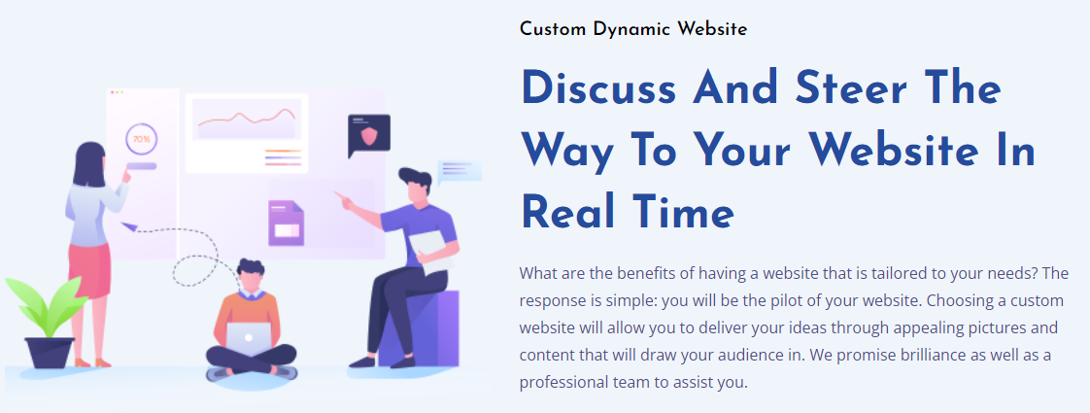

**Get A Custom Dynamic   
Data-Driven Website  
To Unleash Your Real  
Potential**  
We offer custom dynamic website solutions that are backed by state-of-the-art technology. Our team of creative designers, developers, and project managers work closely and follow the project brief as their key to success. We spend sufficient time in understanding and planning the project which ensures smooth execution and proven results.

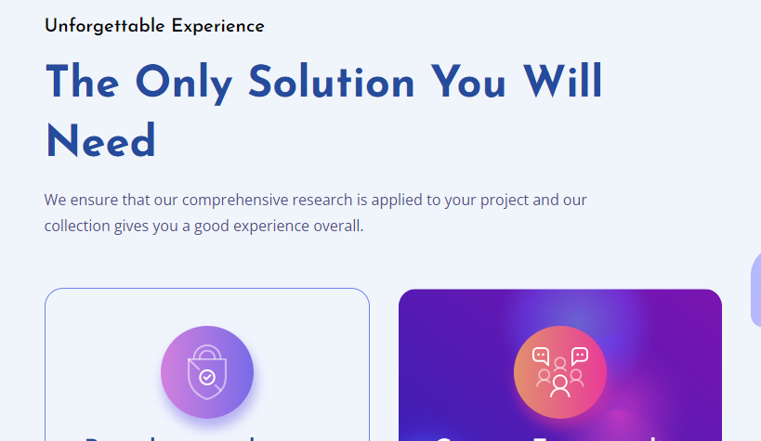

**Unforgettable Brand Experiences**

**Smart Web Solution to  
Boost Your Business**

WebsiteWizardX understands businesses’ dynamic requirements and rapidly evolving industry trends. With our unique mix of digital services, you can grow faster.

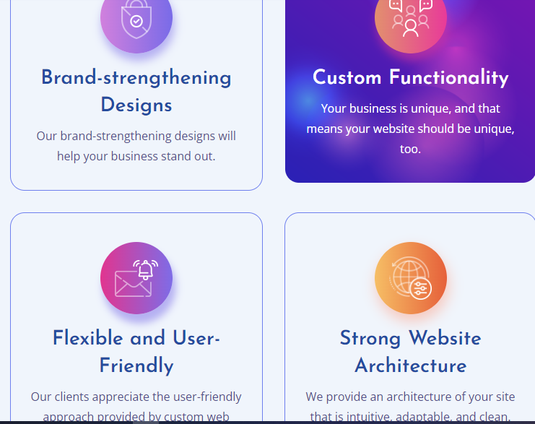

**Brand-Centric Designs**

With our brand-centric design approach, you are all set to stand out.

**Custom Functionalities**

To meet your diverse needs, we can build custom functionalities in your website.

**User-Friendly Experience**

We follow intelligent web creation processes that deliver user-friendly experiences.

**Robust Web Architecture**

Our solutions are backed by technologies that are strong, secure, and agile.

**https://0100.intechnite.com/custom-ecommerce.html**

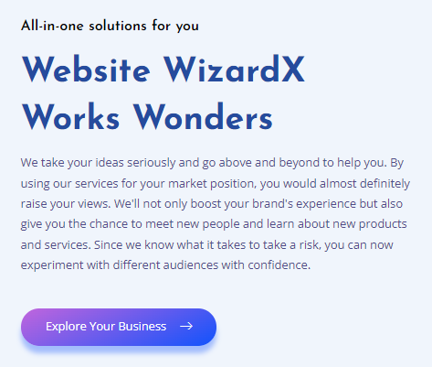

We Can Build A Professional  
**eCommerce Website For  
Your Unique Business Needs**  
Be it fashion, clothing and lifestyle or electronics, healthcare, and digital services, WebsiteWizardX is here to provide you with a high-end eCommerce website. This will enable you to step into the digital space with more confidence and the capacity to compete better and outrun your competitors easily. Our experienced and qualified experts have built numerous eCommerce websites for clients from numerous industries.

[**https://0100.intechnite.com/custom-webapp.html**](https://0100.intechnite.com/custom-webapp.html)

We Make High Performing  
**Custom Web Applications  
For Individuals & Businesses**

Whether you have a small or a large-scale business, we have services and solutions for all your unique requirements. If you want to build a smart and intelligent web application for your target audience, choose us. We have built numerous web apps since we started working and each one of them are still active today. Keep this in mind and give us a chance to build something extraordinary and different from your competitors.

[**https://0100.intechnite.com/custom-mobileapp.html**](https://0100.intechnite.com/custom-mobileapp.html)

We Are a Team of Award-Winning  
**Custom Mobile Application  
Development Experts**  
WebsiteWizardX is ranked among the best and most recommended custom mobile app development agencies. Over the years, we have worked on multiple projects that involved everything from fun, entertainment, and gaming to health, business, and enterprise apps. We are capable of not just making Android and iOS mobile apps but hybrid and VR apps. By choosing us, you will be able to hire mobile app developers who have unmatched portfolios.